1. Site map: 10 points
1. Maps of closed: 10 each
- Roads
- Trails
- Power lines
2. Table of lengths for closures: 30 Points
3. Map of buffered lakes: 10 points
4. Remainder of the report: 20 points
Expected Values (units were not specified in the lab so any units are accepted):

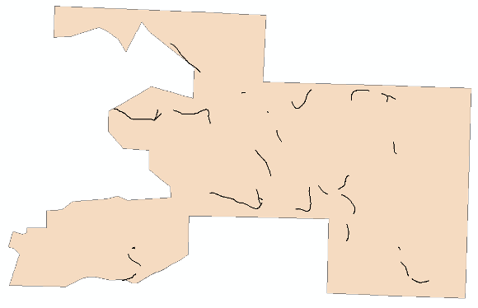
Fire roads clipped to 50 yard stream buffers

