## Points:

- Maps of streams, roads, harvestable area: (40 points)

- Correct answers: (2 points each for 24 points)

- -1 if they are close (within 10 percent), -2 if completely off

- 0 points off if they are within 1 as this can be from rounding.

- Flow charts (10 points each, 20 points)

- Question: (5 points)

- Comes from the spatial reference attached to the layer

- Remainder of the report: (11 points)

## Results

There were some differences in processing that result in variances in the results. Below is a table of the allowable values for the student’s answers. Next term we’ll make the processing more specific to remove the variance.

.

These values are from the Excel spreadsheet in the lab folder.

## Appendix – Calculating the values

**Stream lengths:**

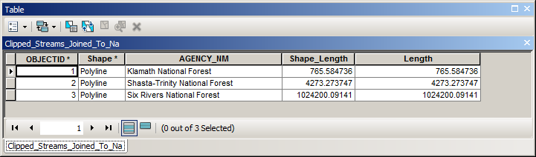

Total:

**Area:**

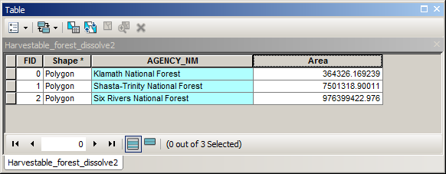

**Roads:**

This part is a bit tricky as they have to “intersect” the national forests and roads to get the roads to split across the national forest boundary. I believe this only shows up with the tiny section of Klamath national Forest where a stream is 207 in length if it is intersected and 375 in length if it is not.

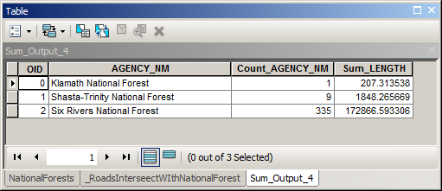

National Forest Amount Allocated:

$ Amount Allocated = .3(stream length) + .1(area) + .2(road length)