1. Site map: 10 points

1. Maps of closed: 10 each

- Roads

- Trails

- Power lines

2. Table of lengths for closures: 30 Points

3. Map of buffered lakes: 10 points

4. Remainder of the report: 20 points

Expected Values (units were not specified in the lab so any units are accepted):



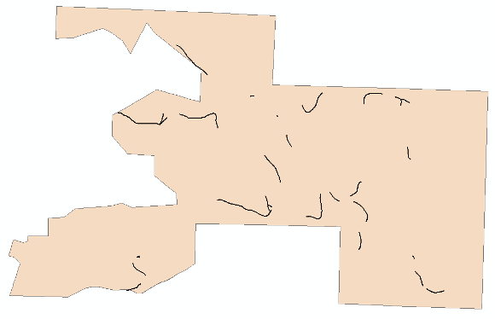

Fire roads clipped to 50 yard stream buffers