Music Festival: Data Acquisition Results

By: Jim Graham

13th of September, 2013

Introduction

Results

Table 1. Dataset information

|  |  |  |
| --- | --- | --- |
| **Name of Dataset** | **Source** | **Issues Discovered** |
|  |  |  |
|  |  |  |
|  |  |  |
|  |  |  |
|  |  |  |
|  |  |  |
|  |  |  |

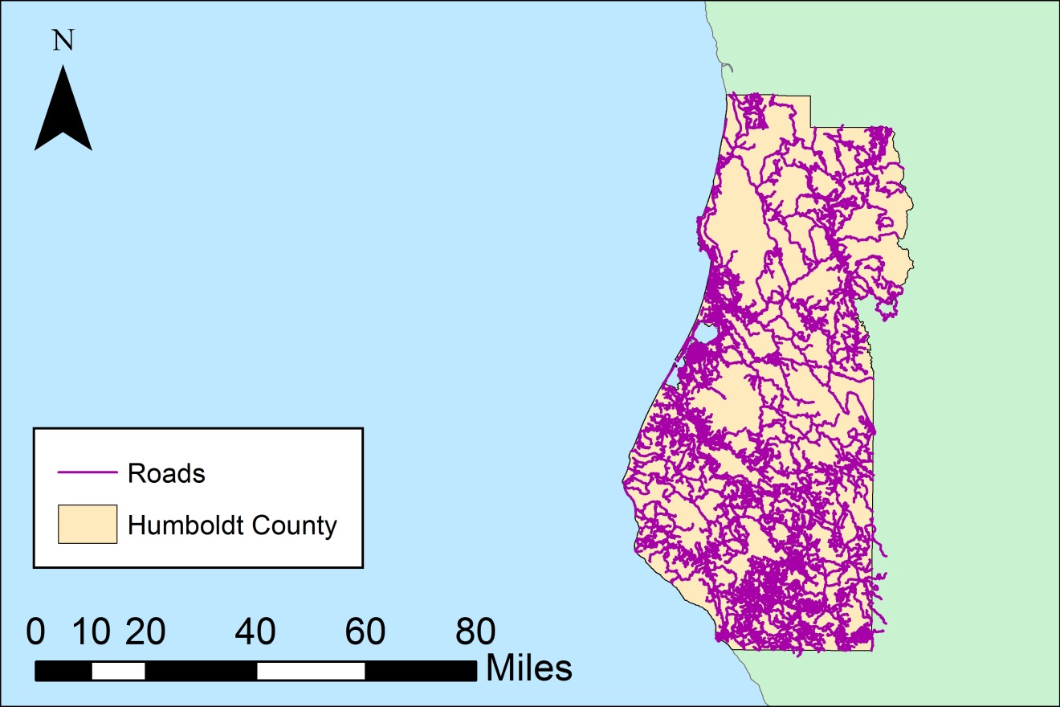

Figure 1. Roads of Humboldt County (Source: Humboldt County, NAD 83 Datum, California State Plane Zone I).