Evaluating Methods for Collecting Spatial Data in Closed Canopies and Rugged Terrain

By: Jim Graham

13th of September, 2020

# Introduction

Geospatial data can be collected with a variety of types of equipment including Hand-Held Global Positioning System (GPS) units, magnetic compasses, and laser range finders. Handheld GPS units vary in their accuracy based on the model and the model and the number of satellites available (Drosos and Malesios 2012). In some situations, researchers can obtain higher accuracy with a compass and laser range finder than with a GPS. However, using a compass and range finder has different accuracy issues (Julián & Daniel, 2015).

The goal of this report is to determine the uncertainty of two types of equipment for collecting spatial data: 1) GPS, and 2) Compass and Range Finder.

# Methods

We obtained a Nikon 16703 Forestry Pro II Laser Rangefinder, a compass, and a Garmin eTrex 10 GPS handheld from the Forestry Stockroom at Humboldt State University. Then, we downloaded the protocol. Then, we created a field sampling protocol document (see Appendix A) with the following data fields:

1. Feature(tree) or Benchmark number
2. GPS Easting
3. GPS Northing
4. Compass Direction (azimuth)
5. Distance
6. Height (optional)
7. Notes

We began the surveys at the entrance to the Arcata Community Forest at the corner of E 14th St. and Union St. in Arcata, California. We established a benchmark by selecting the ____________ feature as it would be visible in aerial imagery. We took a way point at the benchmark and recorded it as Feature 1. We then took compass and distance measurements to the first tree and recorded them in our field sampling protocol document. We moved to the first tree and then repeated this process for ____ trees. At our final tree, we recorded compass and distance measurements to ___ additional trees. We took turns using the equipment to make sure that everyone had a chance to work with each method. We also reviewed each entry as a team to reduce errors in recording.

We began analysis by downloading the waypoints to a computer using DNR GPS version ___ from the Minnesota Department of Natural Resources and loaded them into ArcGIS Pro Version __ from Esri. We exported the waypoints to a Comma Separated Value (CSV) file and then loaded this file into Microsoft Excel version __ and added the GPS coordinates. We loaded the ____________ data set and found a reference coordinate for our benchmark. We used this to compute a Root Mean Squared Error (RMSE) for our benchmark coordinates. In Excel, we applied a declination of ___ to the compass readings and then computed the location of each of the trees based on the compass headings and distances. We compared the GPS coordinates to the coordinates obtained using the compass and range finder.

# Results

The results section is where you should place your final output. This typically includes tables and figures. A good approach is to write text about a result that is shown in a table and/or figure and then reference the table and/or figure and have it follow the paragraph. As an example, the table below shows the results of our analysis of the land use within Humboldt County (Table 1).

Table 1 Summary of land use within Humboldt County

|  |  |  |  |
| --- | --- | --- | --- |
| **Land Use Type** | **Number of Parcels** | **Number of Acres** | **Percent of the Total** |
| Agriculture | 196 | 2713 | 2.1 |
| Religious | 1458 | 50046 | 0.01 |
| Urban | 103 | 400 | 0.7 |
| Industry | 22420 | 17333 | 0.09 |
| Open | 1191 | 1794 | 25 |
| Residential | 103 | 2094 | 5.0 |
| Timber | 3005 | 581221 | 57 |
| Commercial | 1077 | 14480 | 0.08 |
| Public | 23165 | 115593 | 0.6 |
| Tribal | 8026 | 1312892 | 4.0 |

As another example, the figure below shows the spatial distribution of various types of land use within Humboldt County (Figure 2).

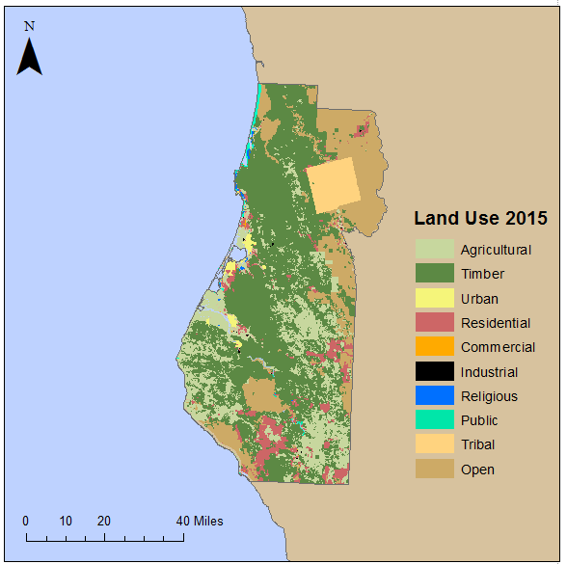

Figure 2 Land use within Humboldt County (Source: Humboldt County GIS)

# Conclusion

State the main findings of your study and discuss the implications of the results. State what you would recommend for the next steps to improve your findings.

# Acknowledgements

Acknowledge anyone that helped with the study that is not otherwise mentioned.

# References

Drosos, Vasileios C. and Malesios, Chrisvaladis (2012). Measuring the Accuracy and Precision of the Garmin GPS Positioning in Forested Areas: A Case Study in Taxiarchis-Vrastama University Forest. Journal of Environmental Science and Engineering B, 2012 , pp. 566-576.

Julián Tomaštik & Daniel Tunák (2015) Compass measurement – still a suitable surveying method in specific conditions, Geodesy and Cartography, 41:1, 31-40, DOI: 10.3846/20296991.2015.1011863

# Appendix A

Add an appendix to include any information you feel is important but does not belong in the body of the text. This could include protocol forms, program listing (i.e. code), additional tables and figures that are too long or numerous for the body of the report.