Mapping Parcels in Humboldt County: Using GIS and ArcMap to analyze farmland based on soil characteristics
By Aaron Pudlicki & Jonathan Wright

Abstract
Agricultural land in Humboldt County is analyzed to find out what areas within it are good for farmland, and are poor for farmland based on soil characteristics. Analysis focused on water holding capacity and soil texture by using data downloaded from Web Soil Survey and the use of ArcMap to create vector and raster files. Soil analysis was performed on farmlands in Humboldt County to determine the best suitable land parcels for agriculture. We found that 37 square miles of the agricultural land is prime soil if it is irrigated. The remaining 19 square miles however, is not prime soil.

Introduction
Humboldt County is a coastal zone that experiences cool winters and dry summers, and receives an average of 51 inches of rainfall annually. According to the Census of Agriculture 2012, Humboldt County has over 3,500 square miles of land, with approximately 593,000 acres of designated farmland and over 930 registered farms. The area is best known for its production of dairy and timberland, and more recently, grass-fed beef.
Currently, there are 50 different soil series mapped out in Humboldt County’s agricultural land (Table 1), however, there are still some areas missing data. In these soil series there are numerous types of soil that are often classified into a small number of categories. Key features in classifying soil are capacity to hold water and soil texture. Humboldt County sits next to the Pacific Ocean and is known for its ability to grow the Coastal Redwood (Sequoia sempervirens) and has the potential to provide a large amount of farmland to California residents (Marris 1982). Humboldt hosts a temperate climate with yearly precipitation varying from 40 - 100 inches depending upon location (Minca 2007).
The intention of this project is to take a closer look into the different soil series’ located in Humboldt County and determine which areas are most suitable for farmland. This study analyzed over 56 square miles of land to determine which areas are ‘Prime if Irrigated’ and areas that are ‘Not Prime’.
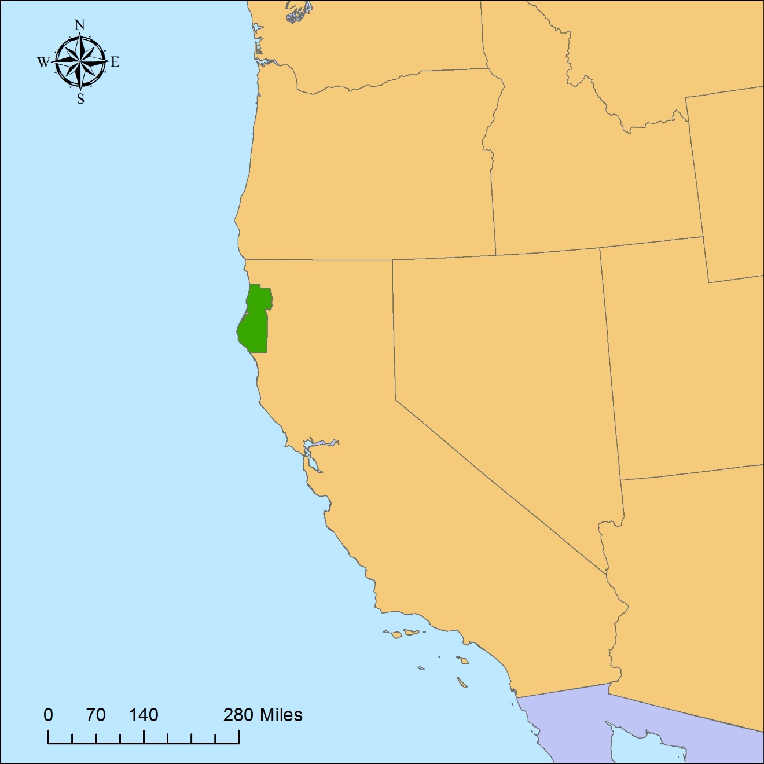
Figure 1. Locator map of Humboldt County, CA where analysis of agricultural parcels with best soil characteristics was performed.

Methods
We first downloaded our data using the Web Soil Survey search engine to use shapefiles created by public agencies: Redwood National and State Parks, Six Rivers National Forest, and Humboldt and Del Norte county geographic information systems (GIS). The shapefiles were then uploaded to ArcMap by Esri, Inc. as well as a county outline of Humboldt and were “clipped” together to create a new raster file. The original shapefiles were combined using the “merge” function and the outlines were turned off to create a clearer and complete shapefile. The spatial reference for the new shapefile was projected as World Geodetic System 1984, geographic.
Soil types were then noted as ‘Not Prime’, ‘Prime if Irrigated’ and ‘Farmland of Statewide Importance’. To classify based on these 3 things we ‘summarized’ the dataset about soil types, then entered a corresponding integer to represent our three different soil types; 1, 2, and 3 respectively. The sum output table then was ‘joined’ to the soil type shapefile. The modified soil type shapefile and a parcels shapefile containing only agricultural land of Humboldt were ‘Intersected’ to create our working site. To calculate area for the ‘Prime if Irrigated’ and ‘Not Prime’ farmland we used ‘Table to Excel’ to export the data to excel where we summed the areas of all the parcels to find the total area for the different soil types in our area of analysis.
Raster analysis then was performed by uploading a digital elevation model (DEM) of Humboldt County. The file was downloaded from the Humboldt County GIS website and clipped to our existing shapefile to analysis the landscape. To run an aspect analysis, we opened the “Spatial Analyst” tab, and under “Surface”, used the “Aspect” tool to determine areas that were south facing. We then ran a slope analysis using the “Slope” tool found under the same function of the “Spatial Analyst” tab. This generated analysis of “Prime if Irrigated” land areas that had a slope less 10%.

Results
Analysis determined that out of the total 56.5 square miles of land parcels designated as farmland, 37.4 square miles are considered ‘Prime if Irrigated’ for farming (Figure 2). These results are based on the soil characteristics of water holding capacity and soil texture. Slope was also a factor in this analysis, however, slope ranged between 0-9 percent and would otherwise be considered flat. Our findings also determined that the soil types with most area in Humboldt County that had the largest amount of ‘Prime if Irrigated’ land were found to have slopes between 0-2 percent. Specifically, soil types Weott, Arlynda, and Russ have 9.9, 5.4, and 3.8 square miles of “Prime if Irrigated’ farmland, as found in Table 1.

Table 1. Soil types that occur in agricultural parcels in Humboldt County
Soil Status | USGS Soil Name | Area
Not Prime | Water and Fluvents, 0 to 2 percent slopes | 0.0599
 | Fluvents, 2 to 5 percent slopes | 0.0039
 | Swainslough-Occidental complex, 0 to 2 percent slopes | 0.4537
 | Fluvaquents-Typic Udifluvents complex, 0 to 2 percent slopes | 8.0086
 | Fluvaquents, 0 to 2 percent slopes | 0.9538
 | Udifluvents, 0 to 2 percent slopes | 1.1610
 | Occidental, 0 to 2 percent slopes | 6.6115
 | Wigi complex, 0 to 2 percent slopes | 0.5233
 | Wigi, 0 to 2 percent slopes | 0.1309
 | Samoa-Clambeach complex, 0 to 50 percent slopes | 0.6716
 | Lanphere, 2 to 75 percent slopes | 0.1133
 | Oxyaquic Udipsamments-Samoa complex, 0 to 50 percent slopes | 0.0511
 | Worswick-Arlynda complex 0 to 2 percent slopes | 0.0265
 | Lepoil-Espa-Candymountain complex, 15 to 50 percent slopes | 0.0391
 | Candymountain, 30 to 75 percent slopes | 0.0407
 | Devilscreek-Panthercreek-Coppercreek complex, 30 to 50 percent slopes | 0.0023
 | Ladybird-Stonehill complex, 30 to 50 percent | 0.1740
 | Ladybird-Trailhead complex, 15 to 30 percent slopes | 0.0006
 | Flintrock-Highprairie complex, 15 to 75 percent slopes | 0.0001
 | Ladybird-Stonehill complex, 30 to 50 percent slopes,cool | 0.0090
Prime If Irrigated | Fluvaquentic Endoaquolls, 0 to 2 percent slopes | 0.4591
Soil Status | USGS Soil Name | Area
Prime If Irrigated | Worswick, 0 to 2 percent slopes | 1.1202
 | Weott, 0 to 2 percent slopes | 9.9458
 | Swainslough, 0 to 2 percent slopes | 2.7238
 | Arlynda, 0 to 2 percent slopes | 5.4616
 | Loleta, 2 to 5 percent slopes | 1.6419
 | Jollygiant, 0 to 2 percent slopes | 1.2198
 | Arlynda, 0 to 9 percent slopes | 0.3746
 | Halfbluff-Tepona-Urban Land, 2 to 9 percent slopes | 0.0387
 | Bigriver-Ferndale-Russ complex, 2 to 5 percent slopes | 0.0003
 | Bigtree-Mystery complex, 2 to 9 percent slopes | 0.0027
 | Pistolriver, 0 to 2 percent slopes | 0.0042
 | Talawa, 0 to 2 percent slopes | 0.0192
 | Tsunami, 2 to 9 percent slopes | 0.0040
 | Russ, 0 to 2 percent slopes | 3.8671
 | Madriver, 0 to 2 percent slopes | 0.8590
 | Kerr, 0 to 2 percent slopes | 0.4476
 | Grizzlybluff, 0 to 2 percent slopes | 0.2478
 | Dungan, 0 to 2 percent slopes | 1.6237
 | Barbercreek, 2 to 5 percent slopes | 2.2688
 | Ferndale, 0 to 2 percent slopes | 3.3874
 | Canalschool, 0 to 2 percent slopes | 1.2990
 | Ferndale, moderately well drained, 0 to 5 percent slopes | 0.0073
 | Megwil and Cannonball soils, 0 to 5 percent slopes | 0.0034
 | Arcata and Candymountain soils, 0 to 2 percent slopes | 0.2097
 | Arcata and Candymountain soils, 2 to 9 percent slopes | 0.1000
 | Lepoil-Candymountain complex, 2 to 15 percent slopes | 0.0111
 | Tillas, 2 to 9 percent slopes | 0.0024
 | Hutsinpillar, 0 to 2 percent slopes | 0.0542
 | Sasquatch-Stonehill complex, 0 to 30 percent slopes | 0.0112

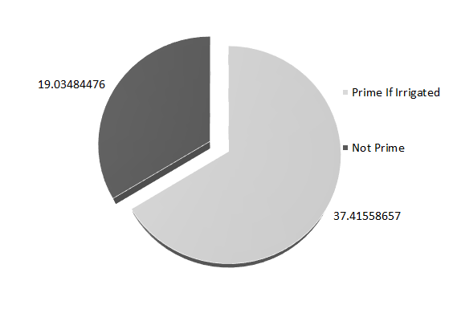
Figure 2. Chart visually showing difference in area (sq. mi.) between ‘Prime If Irrigated’ Agricultural land and ‘Not Prime’ Agricultural land.

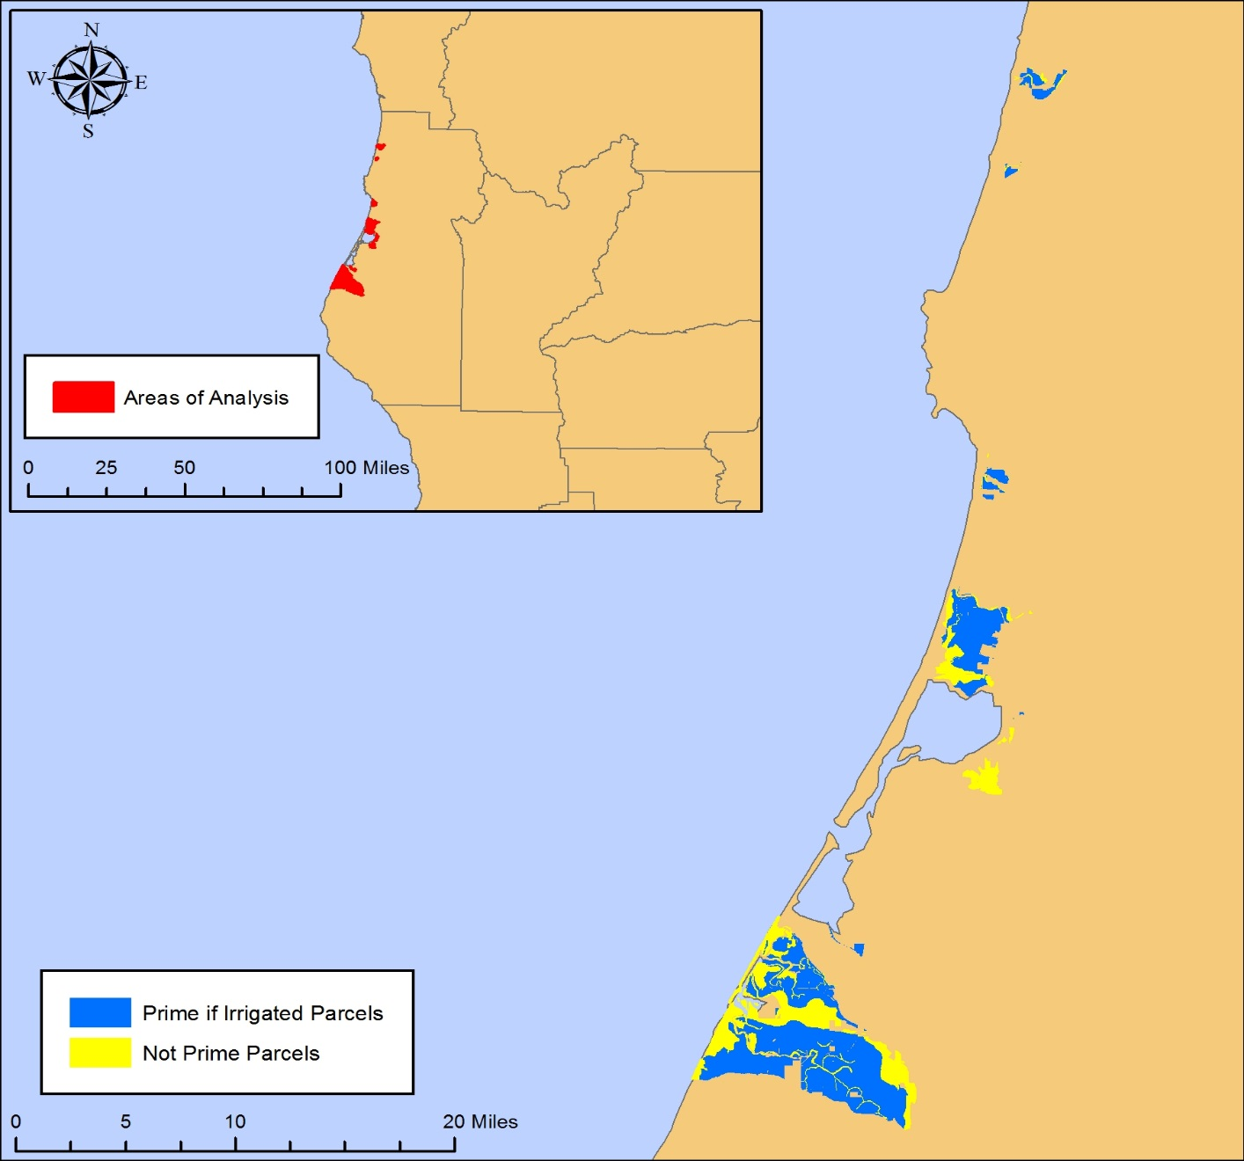
Figure 3: Site map of areas of farmland analyzed in Humboldt County and prime and not prime locations.

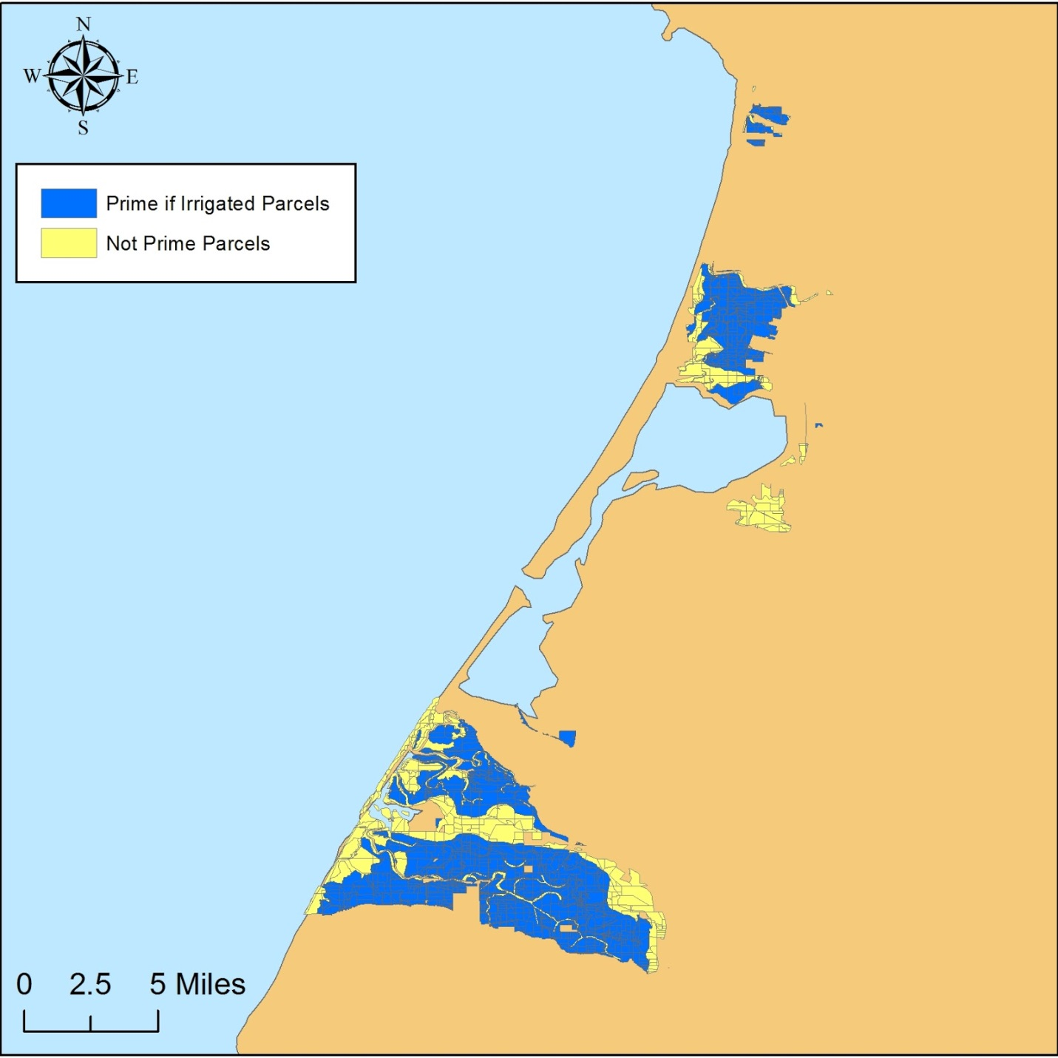
Figure 4: Site map of farmland parcels analyzed depicting prime and not prime areas in Humboldt County, CA.

Conclusion
The analysis of this study determined that there is over 56 square miles of designated farmland in Humboldt County, 37 square miles of which contains ‘Prime if Irrigated’ soil. The soil characteristics are based on their water holding capacity and soil texture. There are many other factors that determine soil fertility, such as: biomass composition, the amount of clay, silt, and sand, and soil porosity. However, the use of GIS and ArcMap in relation to available soil data provided only used soil texture and water holding capacity to generate a more succinct and precise analysis. All of the other soil characteristics mentioned were not available or were incomplete in the data downloaded from Web Soil Survey to use as parameters. This study focused on the basic aspects of soil because the shapefiles had complete information and would allow for a thorough analysis of the land parcels. It is also understood that aspect and slope are important factors to determine suitable soil, but the land analyzed was flat. This would also be a determining factor for land managers and farmers in regards to the types of crops they would grow. This study also did not take into account the type of production the land would be used for and based our analysis on the key components considered most important: soil texture and water holding capacity. Soil types were categorized for all the different soil types in Humboldt County, which was about ten times as diverse. Thus, it is likely that a more in-depth soil analysis could be performed in the agricultural land with only 50 different soil types to find commonality instead of 500.

Acknowledgements
This study was made possible with the help and assistance of Web Soil Survey that provided the necessary characteristics for soil series’ categorization. The data used for this study was provided by Humboldt County GIS and was made available via their website. Shannon Wells provided the background soil analysis categorization needed to determine both ‘Prime if Irrigated’, ‘Not Prime’, and ‘Farmland of Statewide Importance’ land area parcels.

Bibliography
Census of Agriculture, "Recent Census Years." USDA. Web. 25 Apr. 2016.<https://www.agcensus.usda.gov/>
Marris, P, 1982, Community planning and conceptions of change, Routledge & Kegan Paul, ISBN 0710093497.
Minca, C., 2007, Humboldt's Compromise, or the Forgotten Geographies of Landscape, Progress in Human Geography, Volume 31, Issue 2, Pages 179-193.
Planning Commission, “Humboldt 21st Century: General Plan”, Humboldt County Website, Humboldt County Planning Division, March 13th, 2008, <http://humboldtgov.org/273/General-Plan-Update>

