Land Use Surrounding Critical Habitat for the Yellow-Billed Cuckoo in Humboldt County.
Courtney Abajian and Joseph Best

Abstract
In California, the threatened yellow-billed cuckoo’s (Coccyzus americanus) habitat has been reduced dramatically. Within Humboldt County, there is one region that has been designated critical habitat for the cuckoo by the U.S. Fish and Wildlife Service located just east of the mouth of the Eel River, west of Fortuna and north of Ferndale. We used Esri’s ArcMap to analyze how the land parcels within and surrounding the area are used, and how this may affect the cuckoo’s recovery. We found the most dominant land use in the area to be agriculture, which is a significant source of habitat loss. There is also a large parcel used for gravel mining, and other parcels whose zoning suggests they have been significantly disturbed by humans. Though more investigation is necessary, is is apparent that the land surrounding what may be a critical area for cuckoo recovery is being used in ways that do not help the cuckoo.

Introduction
The Western Yellow-billed cuckoo (Coccyzus americanus) is a threatened species in California. According to the North American Breeding Bird Survey (2014) “Cuckoo populations have declined by over 1.5% per year between 1966 and 2014, resulting in a cumulative decline of 53%.” The main cause for the cuckoo population decline is habitat loss mainly, riparian land being converted for agriculture (USFWS 2014). Cuckoos use wooded habitat with dense cover and water nearby, including woodlands with low, scrubby, vegetation, overgrown orchards, abandoned farmland, and dense thickets along streams and marshes (USFWS 2014). The cuckoo is likely to nest in willows and “The presence of at least one willow on the nest site is very important. At the South Fork Kern River, 94 of 95 nests (99%) were in willows” (Laymon et al 1997).
The home range of the cuckoo is large, often exceeding 50 acres, and sometimes approaching 100 acres in extent (Laymon and Halterman 1985). Having a large range and being long distance nocturnal migrants is an issue with this bird because the Cuckoo becomes vulnerable to collisions with tall buildings, cell towers, radio antennas, wind turbines, and other structures (Laymon 1997). Some of the structures that have had an effect on the yellow-billed cuckoo population are just outside the boundaries of the critical habitat.
A critical habitat is an area that a species with a dwindling population can seek refuge for a chance at revitalizing their population. The U.S. Fish and Wildlife Service defines a critical habitat as “A specific geographic area(s) that contains features essential for the conservation of a threatened or endangered species and that may require special management and protection. Critical habitat may include an area that is not currently occupied by the species but that will be needed for its recovery” (USFWS 2014). The designated critical habitat for the cuckoo in Humboldt County is located just east of the mouth of the Eel River, and is west of Fortuna and north of Ferndale (Figure 1).
For the purpose of this assignment we categorized the land use types within the critical habitat into 8 categories (Agriculture, Industrial, City, Residential, Commercial, Gravel Mining, Public, and other. The mixture of land uses within the boundaries of the critical habitat could create issues with habitat suitability. Yellow-billed cuckoo habitat suitability have been reduced dramatically by the “Replacement of native riparian habitats by invasive non-native plants, particularly tamarisk”(Laymon 1997). The habitat The microhabitat requirements of the cuckoo are also very selective “characterized by higher canopy closure, higher foliage volume, intermediate basal area, and intermediate tree height when compared to random sites” (Laymon et al., 1997). This becomes an issue when there is multiple land uses in the area deemed critical habitat for the cuckoo.
Habitat is not the only not the only factor leading to the decline in the cuckoo population. Reproduction is a slow process for the cuckoo. Yellow-billed cuckoos are asynchronous egg layers which means they do not lay all of their eggs at once, can lay two eggs five days apart. (Laymon et al., 1997). This timing discrepancy can have the oldest chick leaving the nest while the youngest is just beginning to hatch. The time period between hatching siblings can become an issue when food-supply is limited causing the youngest to be removed from the nest by the father (Laymon et al., 1997).
We hope to determine the effects of the different land uses on the habitat of the yellow-billed cuckoo along with assessing the different factors limiting their population. To assess the suitability of the Humboldt County critical habitat for the yellow-billed cuckoo we assessed the different land uses within the boundaries using ArcMap. We compared the different amount of area taken by each land use and analyzed the effect the land use will have on the cuckoo population.

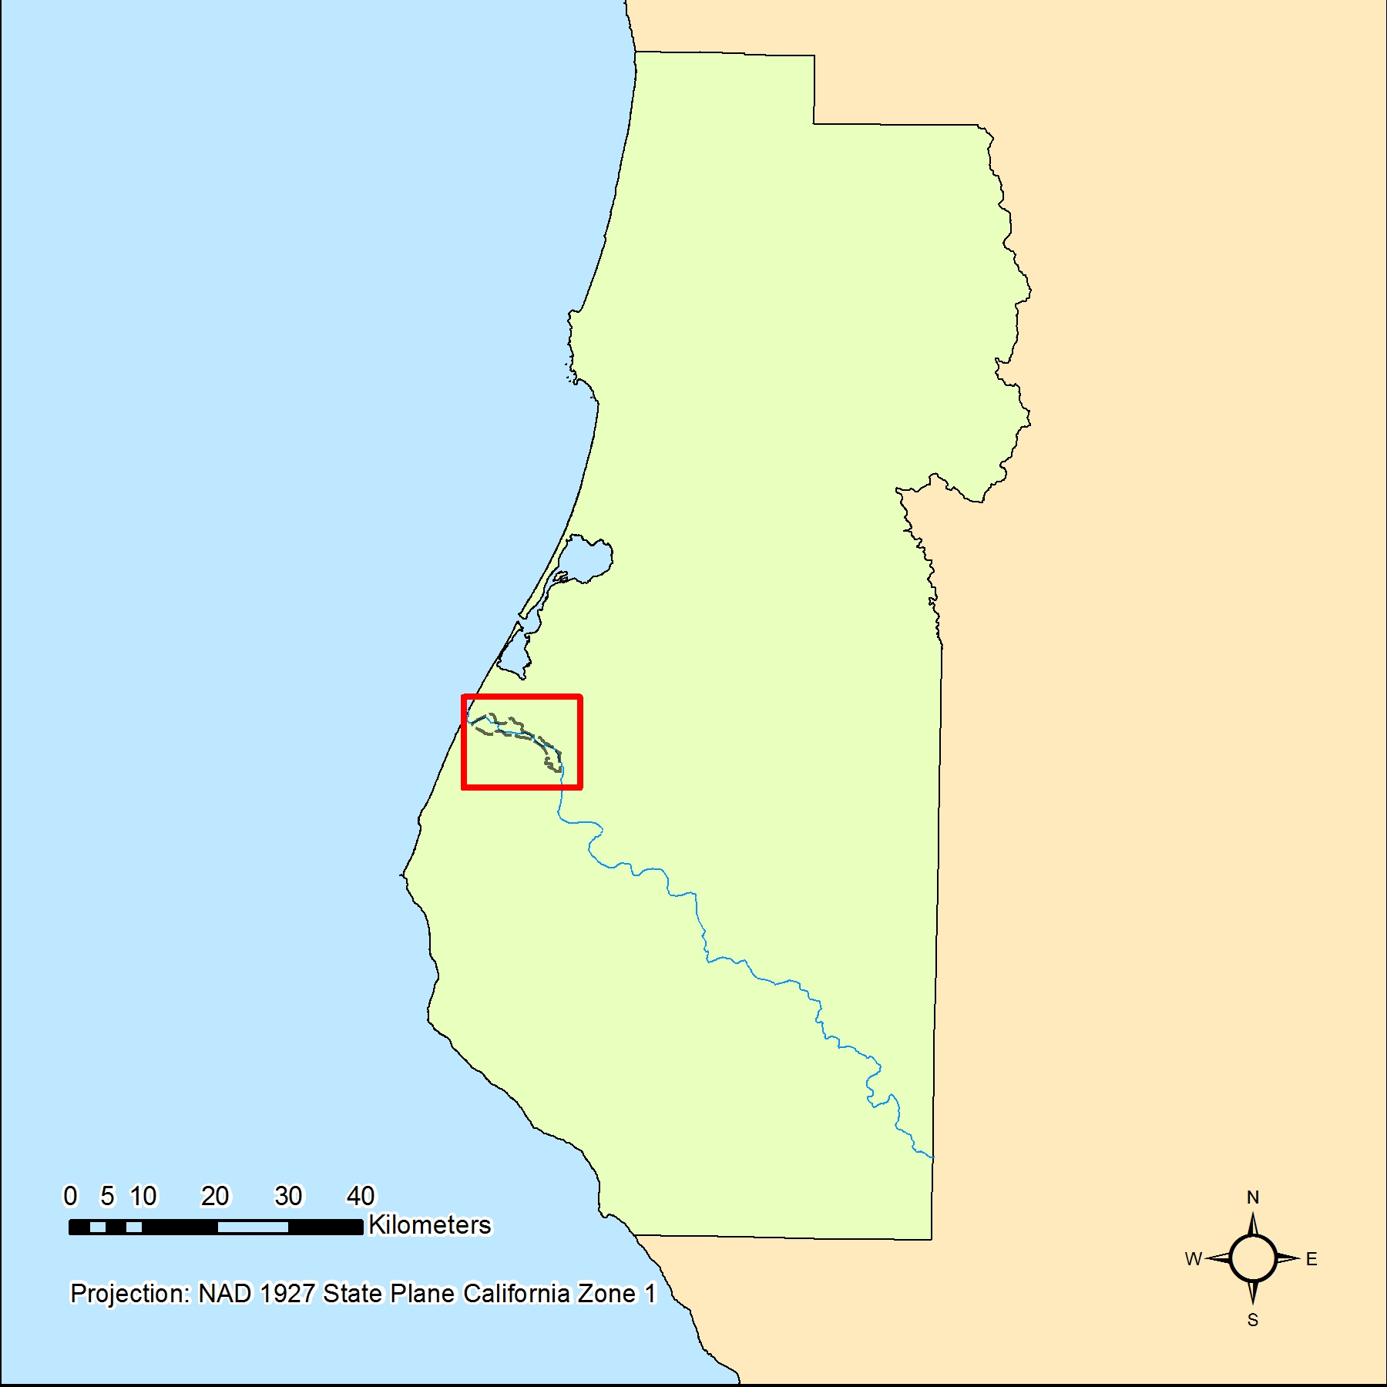
Figure 1: Location of yellow-billed cuckoo critical habitat in Humboldt County, CA.

Methods

We conducted our analysis in Esri’s ArcMap program. We downloaded data from the Humboldt County and USFWS websites. We prepared our data for analysis by projecting all data to D 1927 State plane California Zone 1, which is the spatial reference commonly used for data in Humboldt County and clipping all data to the extent of Humboldt County.

We used the ‘select by location’ geoprocessing tool to select all parcels from the zoning layer within 300 meters of the critical habitat. We then created a new layer from this selection and created a summary table. To make interpretation easier, we reclassified the many land use categories into just 8: “agriculture,” “industrial,” “city,” “residential,” “commercial,” “gravel mining,” “public,” and “other.” We were able to join this summarized table back to the parcels’ attribute table, then create a map clearly displaying the different types of land use surrounding the critical habitat.

To find out what the area of each land use category was, for each individual category we selected by attribute, and then used the field calculator to find the areas of the parcels in the category. We could then look at the statistics window of the selected parcels to find the sum of their areas.

Results
Our analysis resulted in a map showing the different categories of land use around the cuckoo’s critical habitat, as well as the total area of each category. The vast majority of the area is zoned for agriculture, and there are two large gravel mining sites on the river and well within the critical habitat area.

Table 1: Area in square meters of each land use category within and surrounding yellow-billed cuckoo critical habitat it Humboldt County, CA.
Land Use Type | Area (Square Meters)
Agriculture | 34,729,981.24
Industrial | 174,607.51
City | 425,322.82
Residential | 989,889.68
Commercial | 117,367.10
Gravel Mining | 906,787.21
Public | 3,461,741.16
Other | 908,847.46

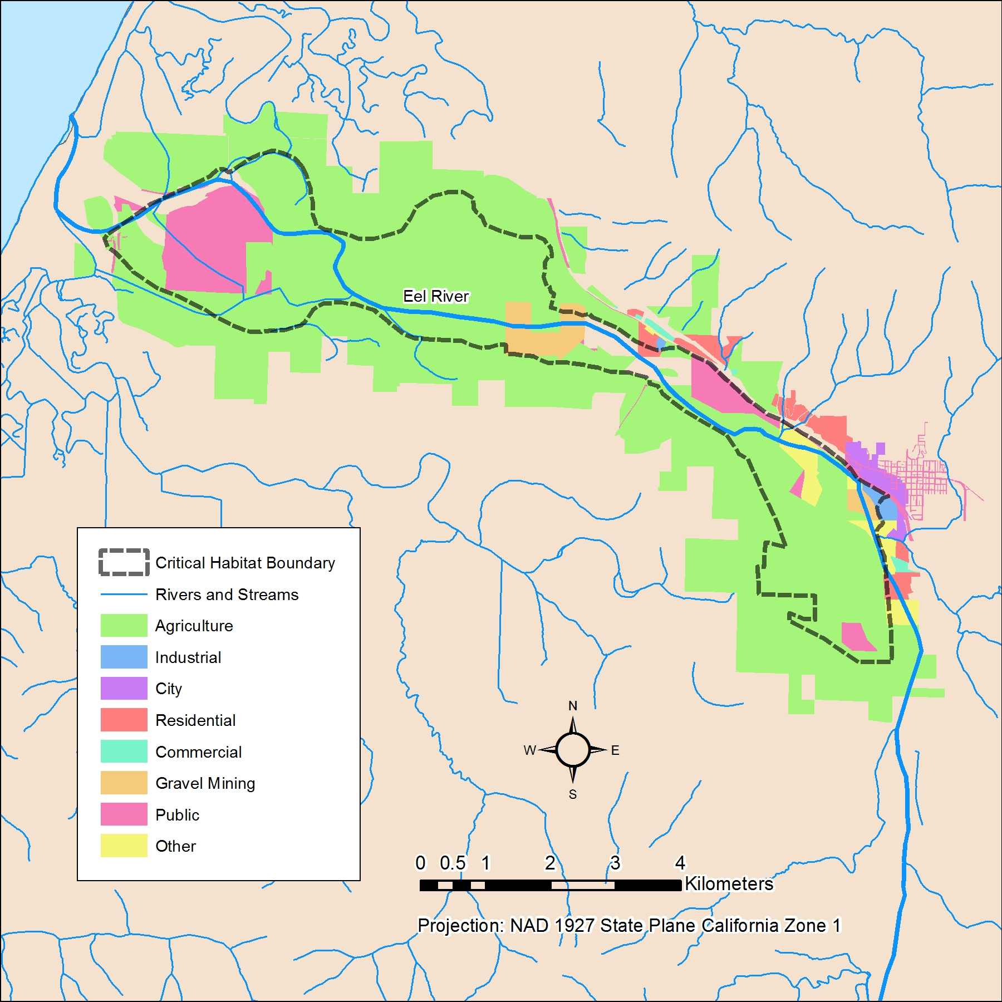
Figure 2: Land use zoning within and surrounding yellow-billed cuckoo critical habitat in Humboldt County, CA.

Conclusion
The area deemed critical habitat (USFSW) within Humboldt County for the threatened Yellow-billed cuckoo has multiple factors that could potentially influence the abundance of the bird. The critical habitat has multiple land uses occurring within the boundaries. The most abundant land type within the Yellow-billed cuckoo critical habit is agriculture, covering a total of 34,729,981 meters. The most influential factor leading to riparian habitat loss within the critical habitat are for use of agricultural lands.
The problem with having agriculture as the most dominant land cover use within the critical habitat is that habitat loss due to agriculture is the leading cause of population decline. The conversion of riparian habitat can severely alter the abundance of yellow-billed cuckoos within a habitat (Laymon 1997). In the literature the most dominant nesting tree for the yellow-billed along the Kern River near the City of Sacramento was the Willow tree. More research needs to be done into the biological make up along the Eel River to establish if there is adequate habitat and a fair number of willow trees or trees of suitable nesting for the yellow-billed cuckoo.
Having a major freeway (101) and a city just outside the bounds of the critical habitat poses another issue. Yellow-billed cuckoos are nocturnal migrants and the presence of tall buildings, cell towers, radio antennas, wind turbines, could influence the yellow-billed cuckoo population abundance. The effects of the city's and the structures stated above in the vicinity of the Humboldt County yellow-billed cuckoo critical habitat need to be monitored and taken into account.
Gravel mine sites located inside of the critical habitat could limit habitat use of the yellow-billed cuckoo (Stalmaster 1978 and Marcus 2007). Examples from the literature on other bird species such as the least tern (Sternula antillarum) and piping plovers (Charadrius melodus) showed that gravel mines pose a huge disturbance to these birds limiting their nesting areas(Marcus 2007). Another study from the literature on the Bald eagle (Haliaeetus leucocephalus) showed how gravel mining can be a large disturbance to the habitat of the bald eagle and can cause the bald eagle to abandon their nests. These studies in mind more research in the effects on gravel mining on bird populations especially birds that are Federally listed under the Endangered species act like the yellow-billed cuckoo.

Acknowledgements
Data for Humboldt County hydrography, zoning, and boundary was downloaded from the Humboldt County GIS portal (http://www.humboldtgov.org/201/Maps-GIS-Data). The yellow-billed cuckoo critical habitat boundary data came from the USFWS Sacramento Office’s Critical Habitat Data page (http://www.fws.gov/sacramento/es/Critical-Habitat/Data/es_critical-habitat_data.htm).

We would like to thank James Graham and Buddhika Madurapperuma for their instruction, patience, and helpfulness throughout the semester.

Bibliography
Critical Habitat." U.S. Fish and Wildlife Service. N.p., 14 Apr. 2014. Web. 25 Apr. 2016.
Daw, Sonya. "Western Yellow-billed Cuckoo." National Park Service, Nov. 2014. Web. 25 Apr. 2016.
Laymon, S.A., P.L. Williams, and M.D. Halterman. 1997. Breeding status of the Yellow-billed Cuckoo in the South Fork Kern River Valley, Kern County, California
Laymon, S.A. and M.D. Halterman. 1985. Yellow-billed Cuckoos in the Kern River Valley: 1985 population, habitat use, and management recommendations. California Department of Fish and Game, Nongame Bird and Mammal Section Rept. 85.06.
Marcus, J.F. and J.J. Dinan. 2007. Directing Nest Site selection of least Terns and Piping Plovers. Waterbirds 30: 251-258.
Sauer, J. R., J. E. Hines, J. E. Fallon, K. L. Pardieck, D. J. Ziolkowski, Jr., and W. A. Link. 2014. The North American Breeding Bird Survey, Results and Analysis 1966 - 2013. Version 01.30.2015 USGS Patuxent Wildlife Research Center, Laurel, MD
Species Information, Yellow-billed Cuckoo." Sacramento Fish and Wildlife. U.S. Fish and Wildlife Service (USFWS), 22 Sept. 2015. Web. 26 Apr. 2016.
Stalmaster, M.V. and J.R. Newman.1978. Behavioral Responses of Wintering Bald Eagles to Human Activity. The Journal of Wildlife Management 42:506-513.
USFWS. 2014. U.S. Fish and Wildlife Service. Endangered and Threatened Wildlife and Plants; Determination of Threatened Status for the Western Distinct Population Segment of the Yellow-billed Cuckoo (Coccyzus americanus); Final Rule. Federal Register Vol. 79. No. 192. Oct 3, 2014.

